TASK 10:

* Learn about Site-to-Site VPN gateway.
* Create two Virtual Network (AzVnet &amp; OnPremVnet)
* Deploy one Virtual Machine on each Virtual Network.
* Setup the Site-to-Site connectivity using RRAS.

**Learning:**

A site-to-site virtual private network (VPN) refers to a connection set up between multiple networks. This could be a corporate network where multiple offices work in conjunction with each other or a branch office network with a central office and multiple branch locations.

Steps:

Step 1: Create two virtual network AzVnet and OnPremVnet

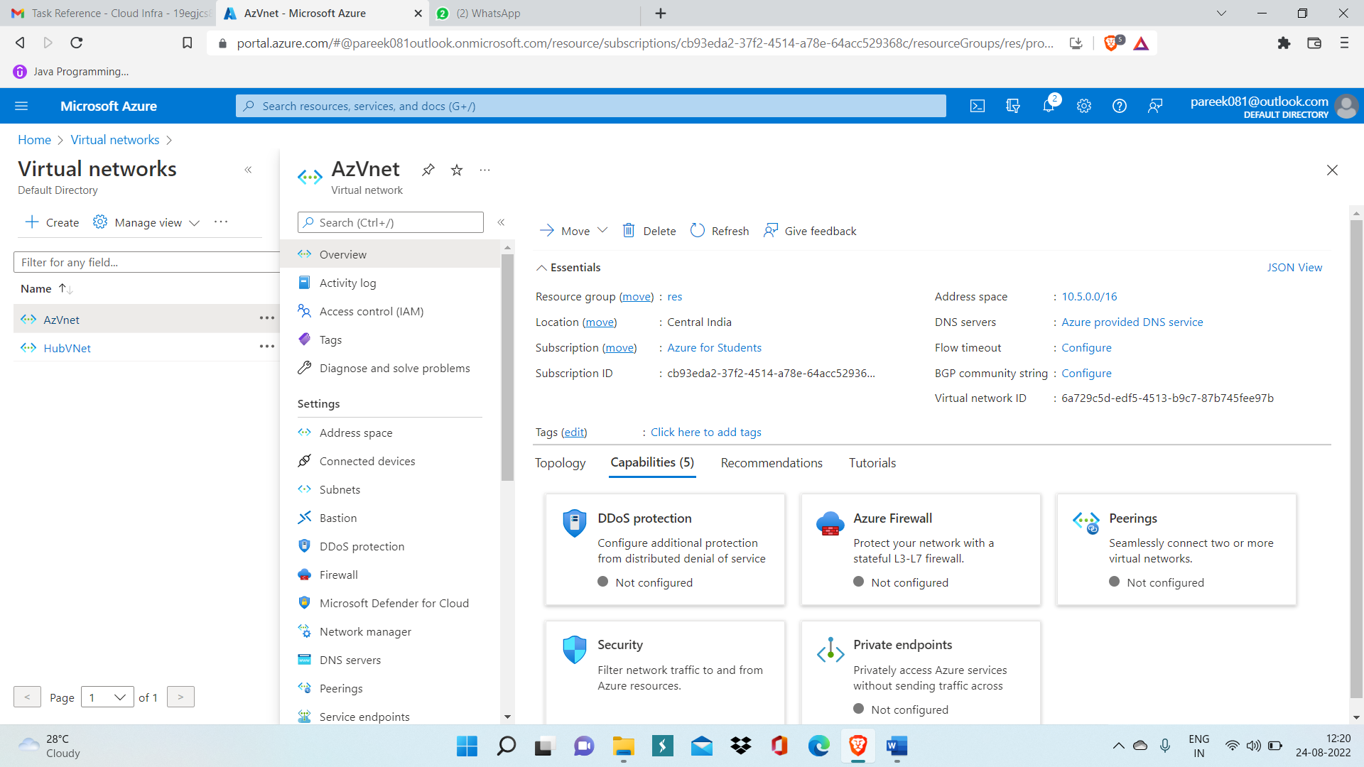

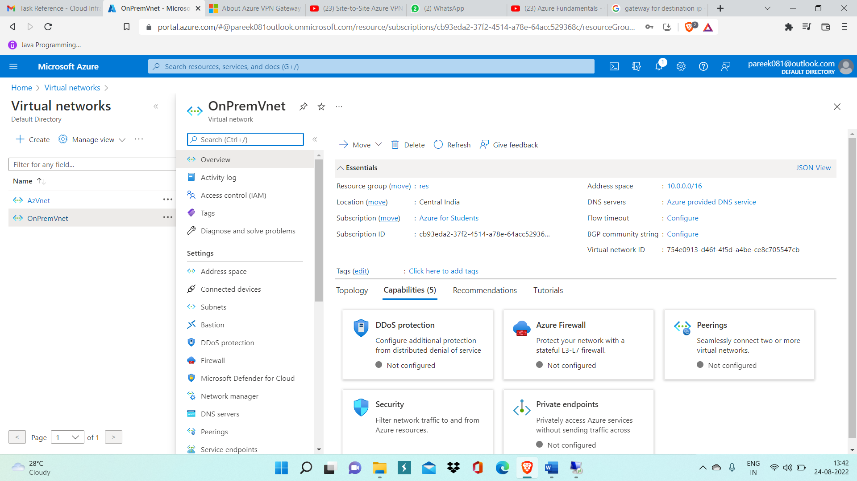

Step 2: Create Vnet Gateway with name ‘vnet-s2s-gw’ and deploy it.

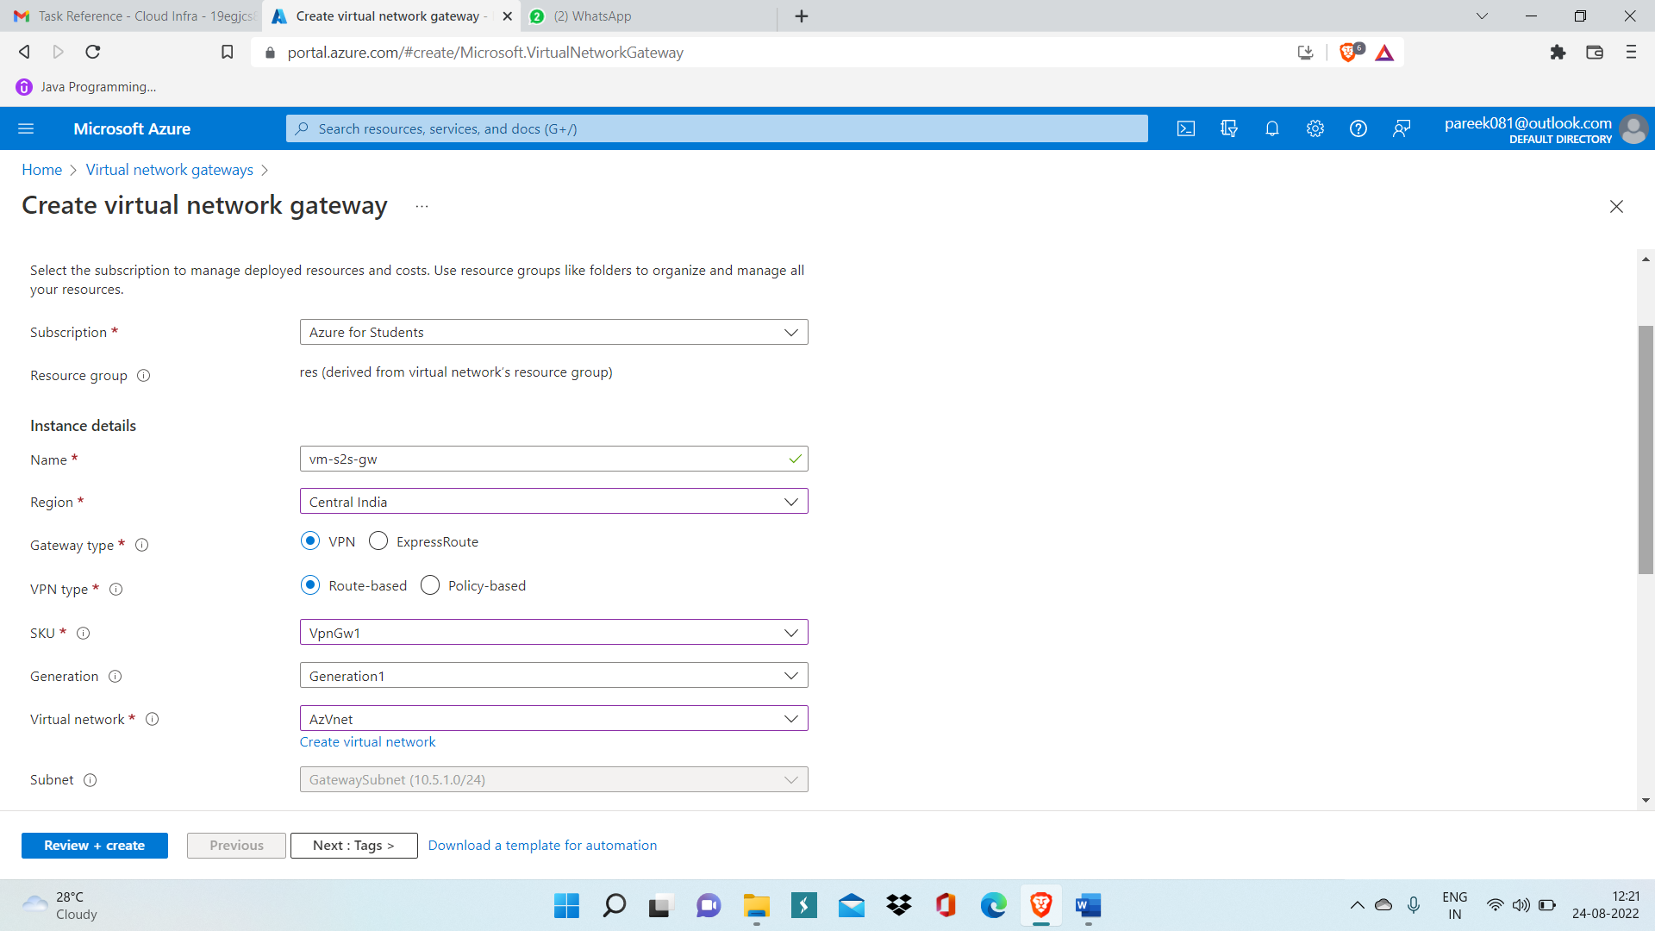

Step 3: Create one VM in AzVnet and create another VM in OnpremVnet.

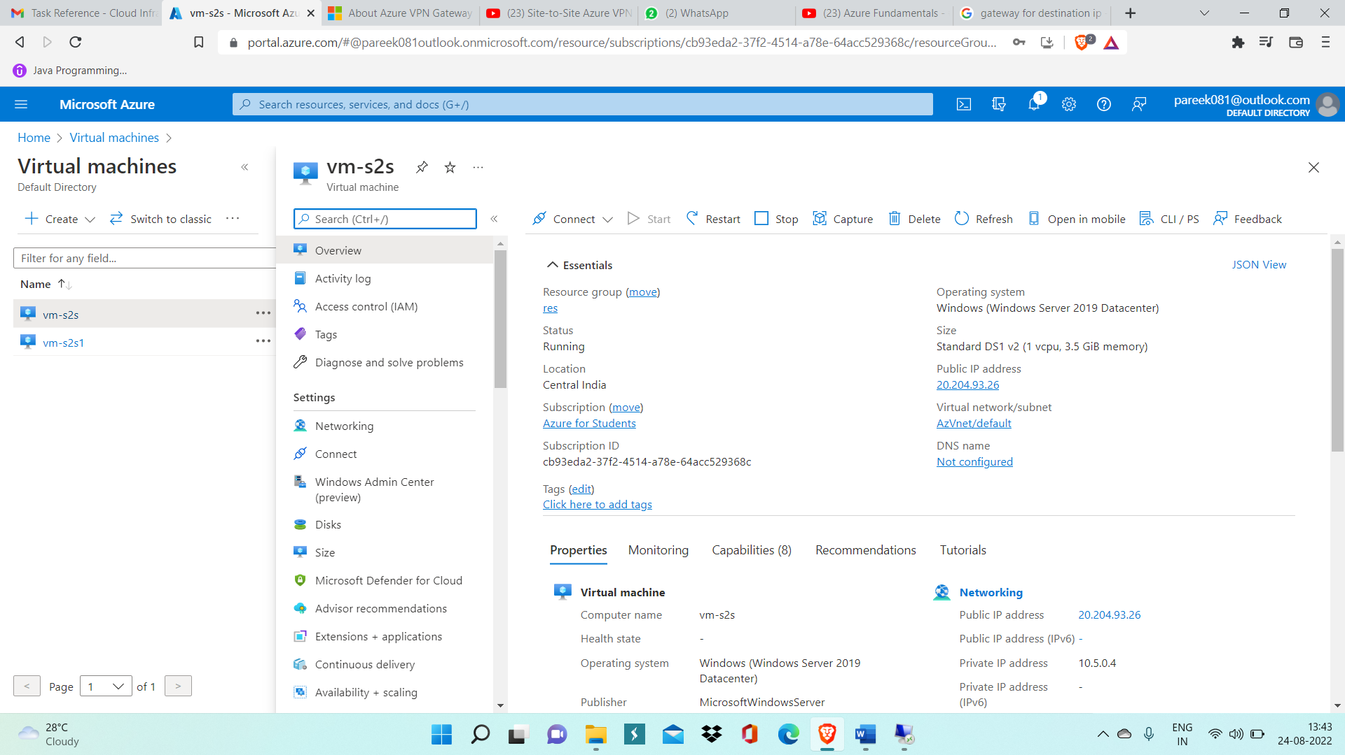

Step 4: Inside Server Manager Add remote access service.

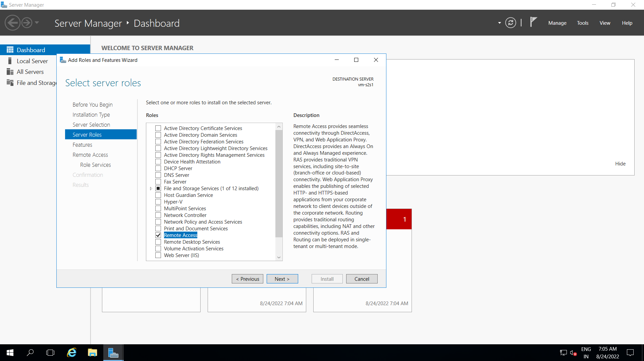

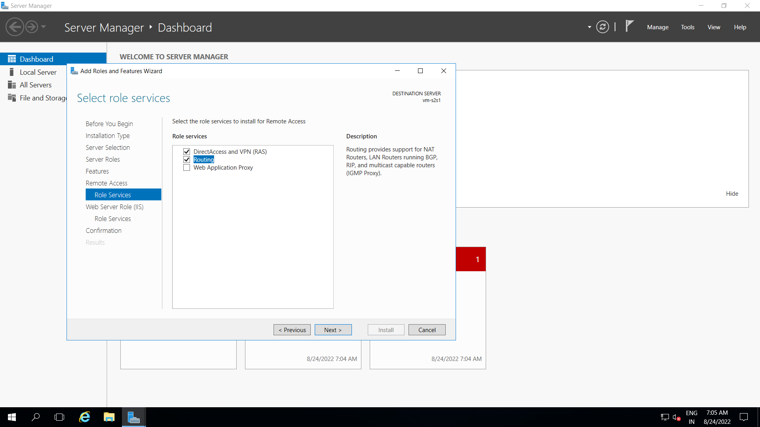

Step 5: Open Routing and Remote Access Wizard

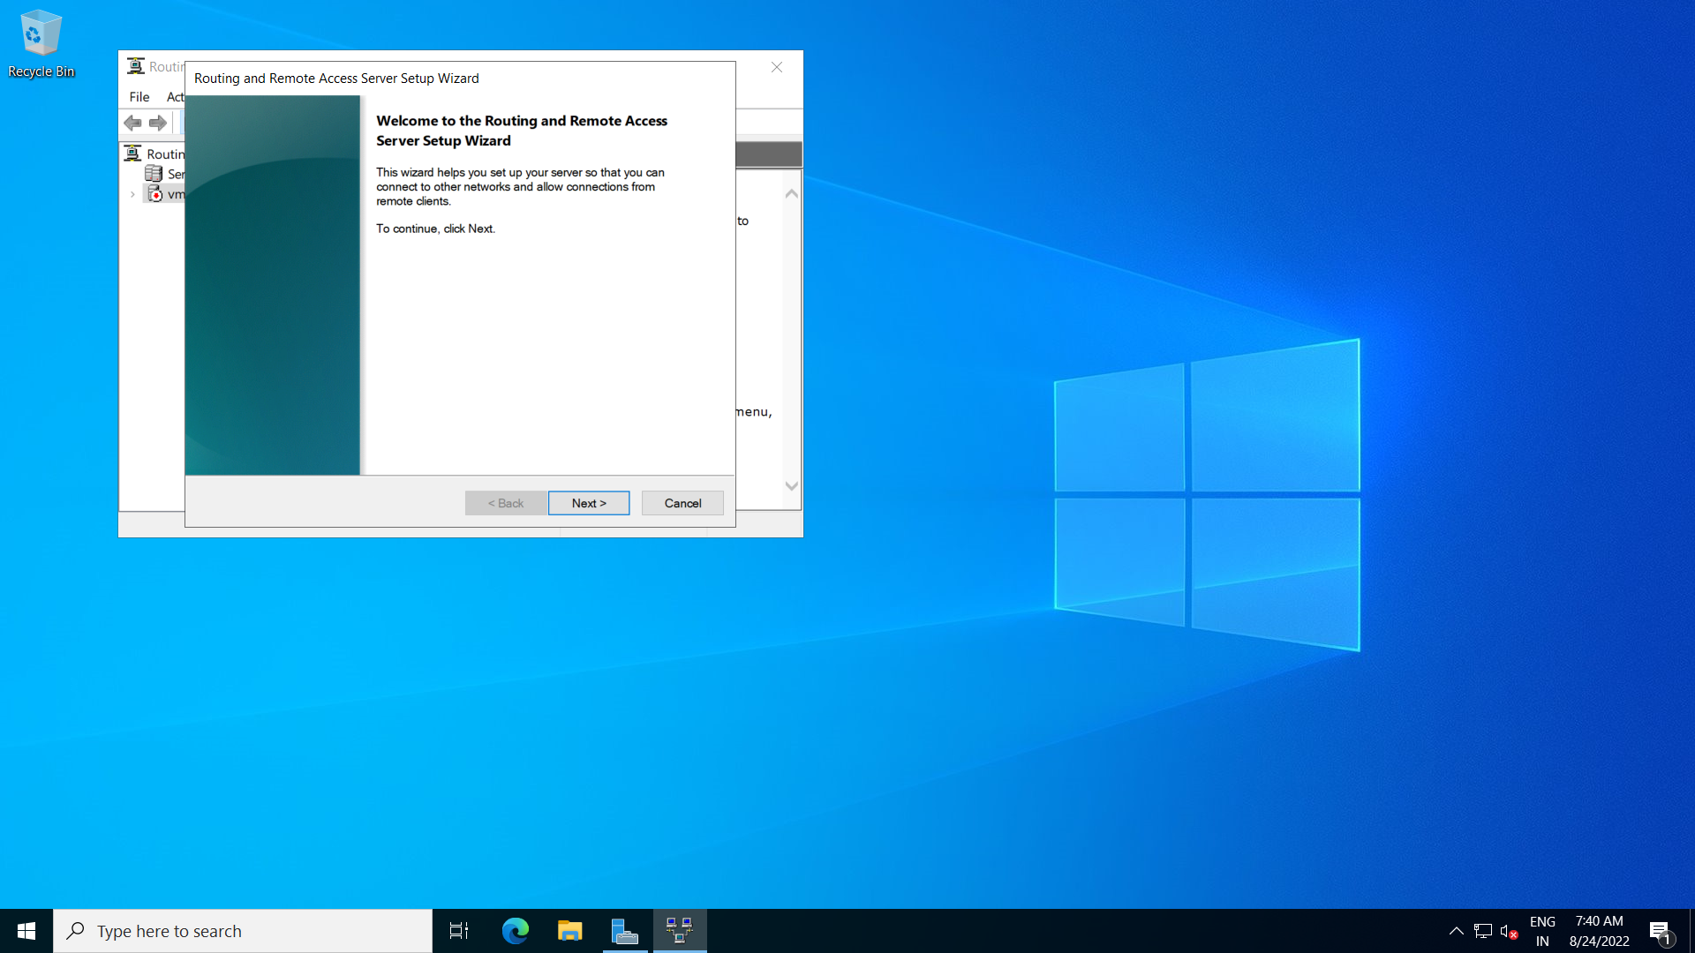

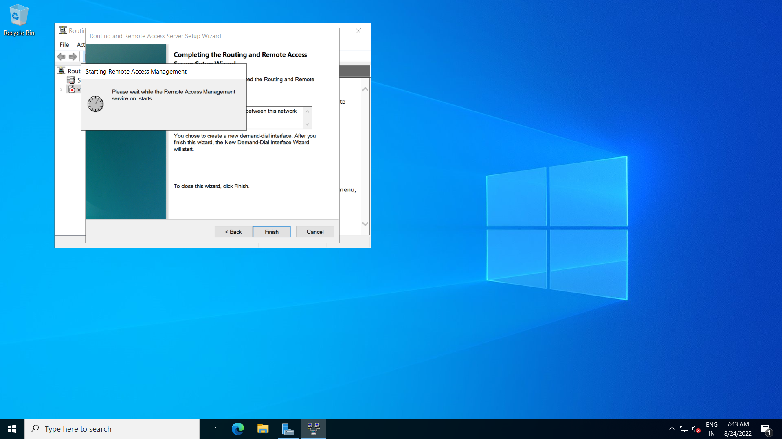

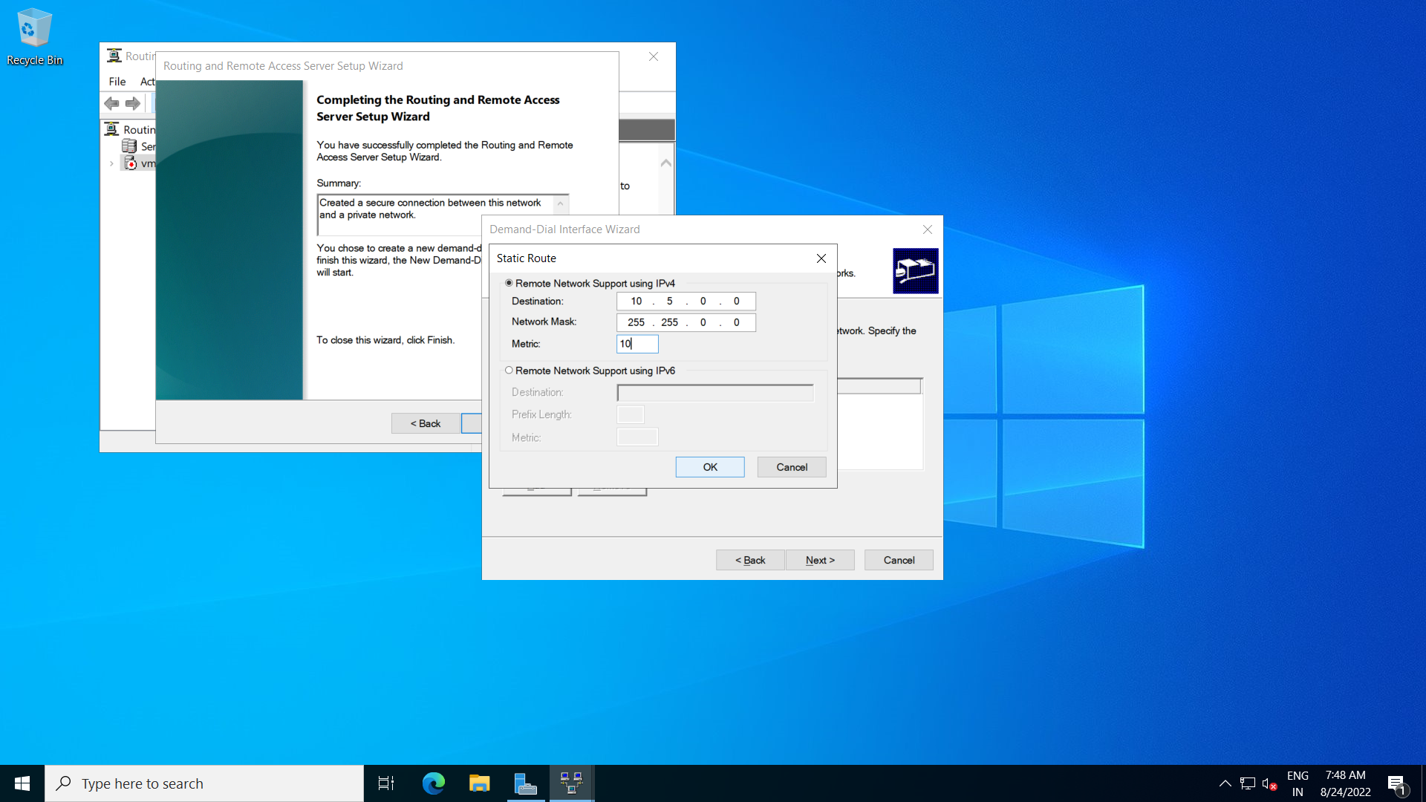

Step 6: Add Static Routes inside IPv4.

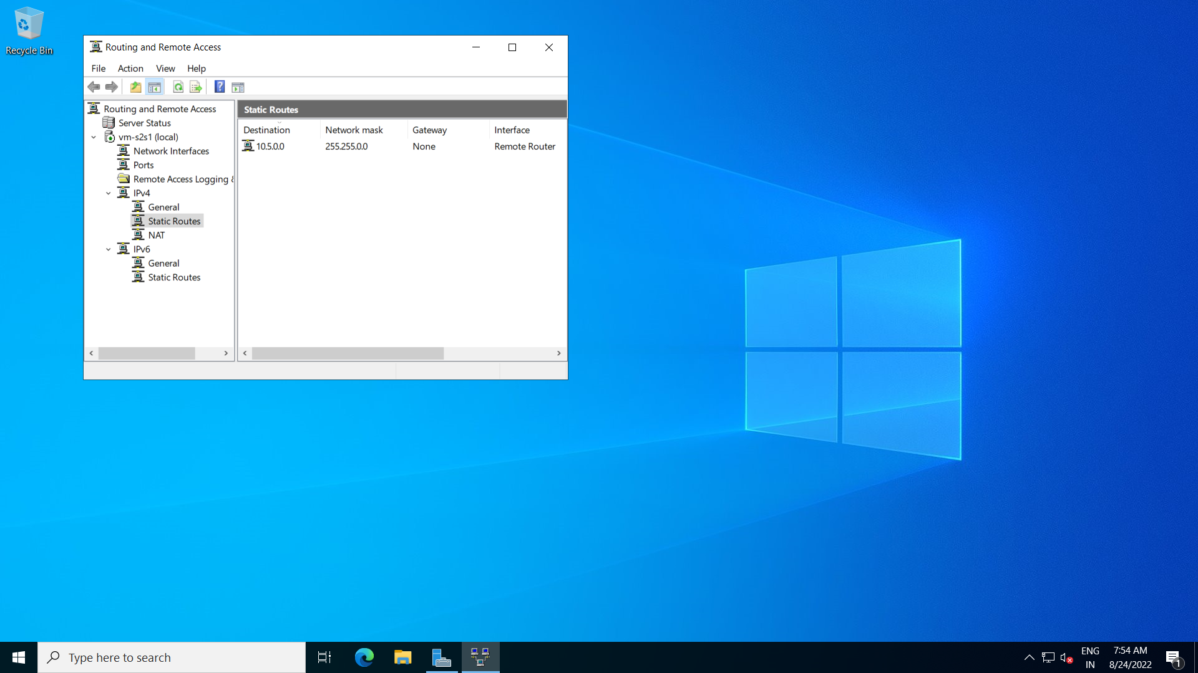

Step 7: Create local network gateway

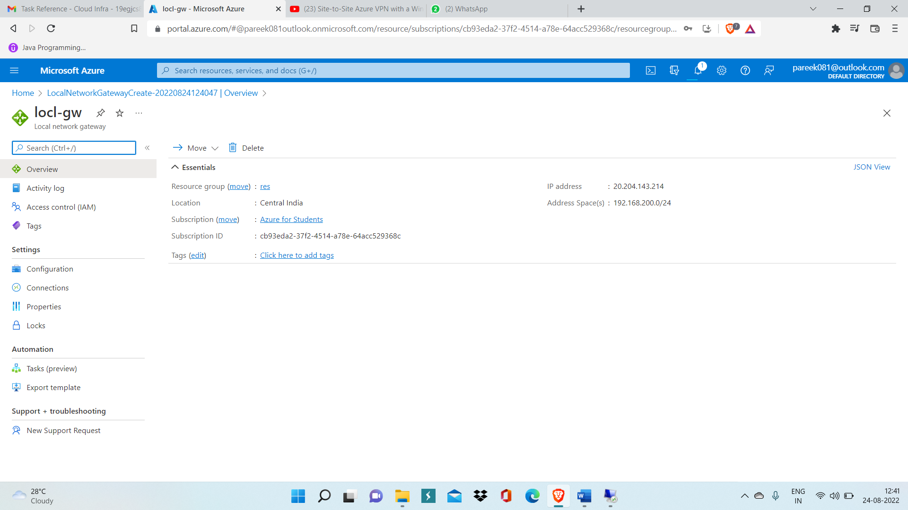

Step 8: Inside Local network gw go to connection settings

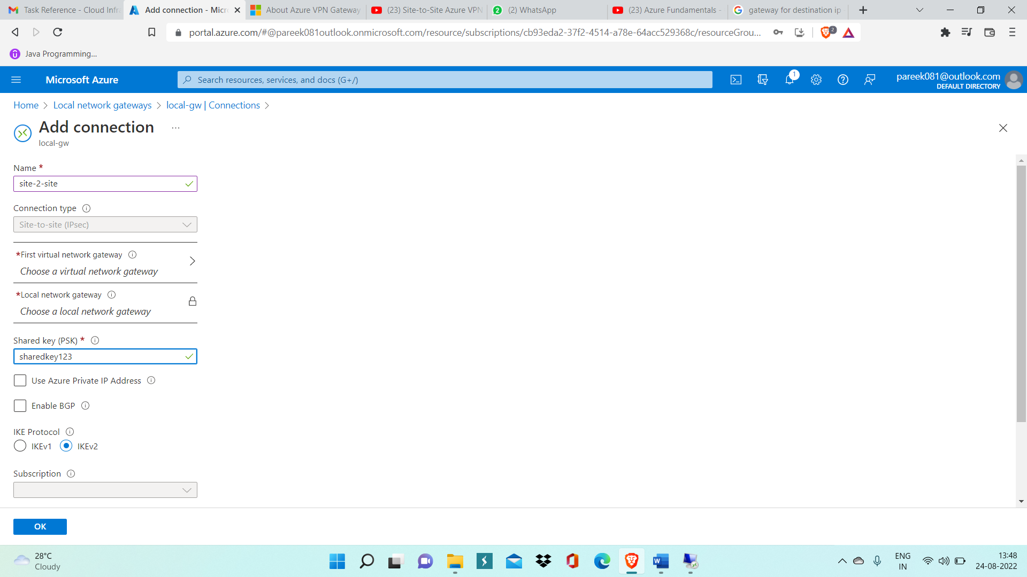

Step 9: Now after connections is added, verify the connection

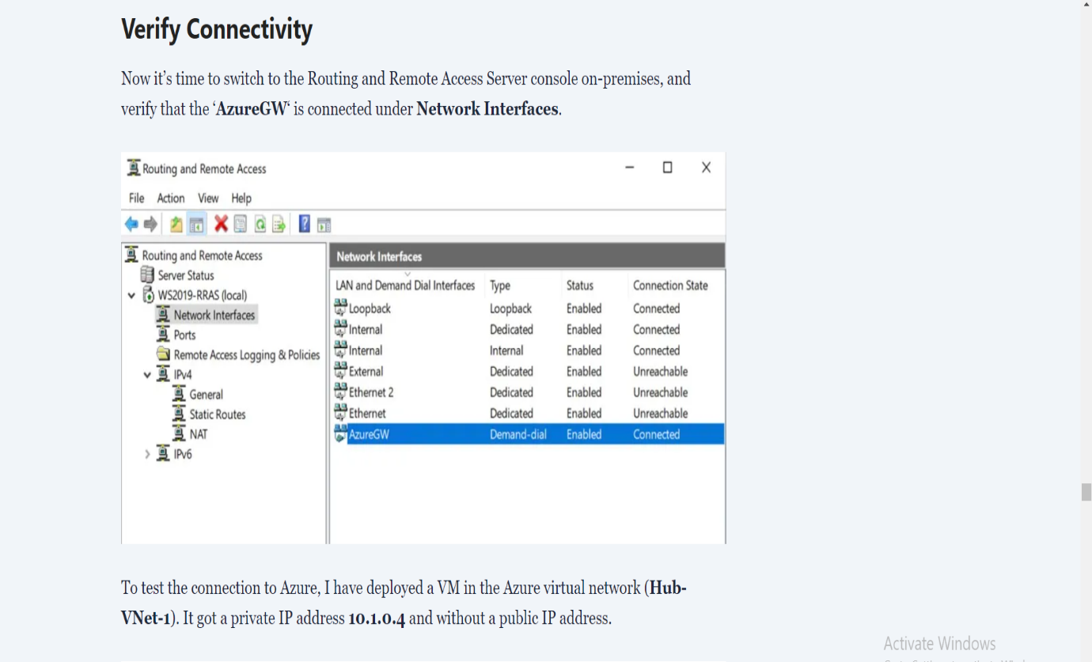

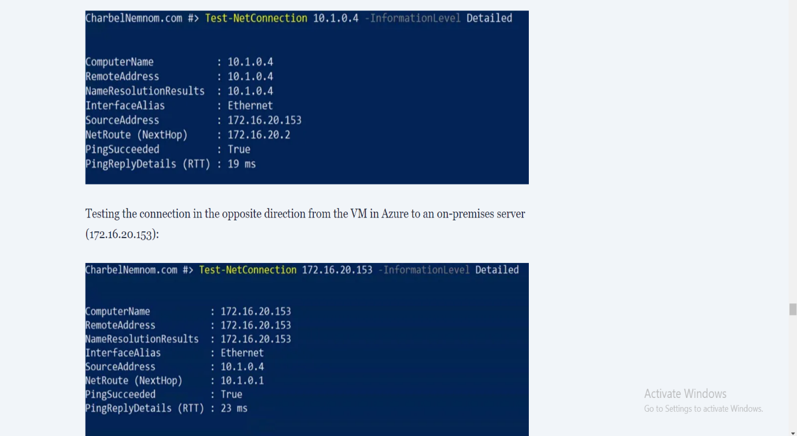

This shows s2s connection is properly created.